PROJECT DESIGN PHASE-II
SOLUTION REQUIREMENTS
Functional & Non-Functional Requirements
Project Name | AI BlogNest API
Team ID | SWTID-2026-7288
Date | 24 September 2026
Maximum Marks | 4 Marks
The solution requirements below retain the reference document's two-part structure while adapting the requirement details to the supplied AI BlogNest source modules. The emphasis is on the actual backend responsibilities visible in the middleware, blog controller, AI router/service, comment model and MongoDB connection.
Functional Requirements
FR No. | Functional Requirement (Epic) | Sub Requirement (Story / Sub-Task)
FR-1 | User Authentication & Role Management | • Validate JWT Bearer tokens for protected requests  • Reject missing, malformed, invalid or expired tokens with authentication errors  • Load the authenticated user from MongoDB and verify the account is active  • Attach the authenticated user context to the request for downstream operations  • Enforce role-based access through reusable authorization middleware
FR-2 | Blog Content Lifecycle & Reader Interaction | • Create posts with title, excerpt, content, category, tags, media and author details  • Generate URL-safe slugs and avoid duplicate slugs  • Support draft, pending, published, rejected and scheduled states  • Retrieve posts using status, category, tag, search and pagination filters  • Apply ownership rules for updates and deletion, while supporting admin/editor management  • Track views, likes and saved posts for reader engagement  • Provide following-feed retrieval and aggregate blog analytics
FR-3 | AI-Assisted Content Services | • Generate multiple blog ideas from a topic  • Generate a complete blog with title, excerpt, headings, useful content and selected tone  • Improve supplied content for clarity, grammar and readability  • Summarize blog content into concise bullet points and a short summary  • Provide a focused BlogNest assistant chat capability  • Generate FAQ questions and answers for a chosen topic  • Route protected AI requests through the dedicated AI router and Gemini service
FR-4 | Comments, Moderation & Content Discovery | • Attach each comment to its post and author  • Trim comment text and enforce a 1,000-character maximum  • Maintain moderation states including pending, approved, spam and rejected  • Submit new comments in a moderation-first state rather than immediate public approval  • Return only approved comments when a post is viewed  • Support project-level keyword and semantic discovery requirements where the related search modules are connected
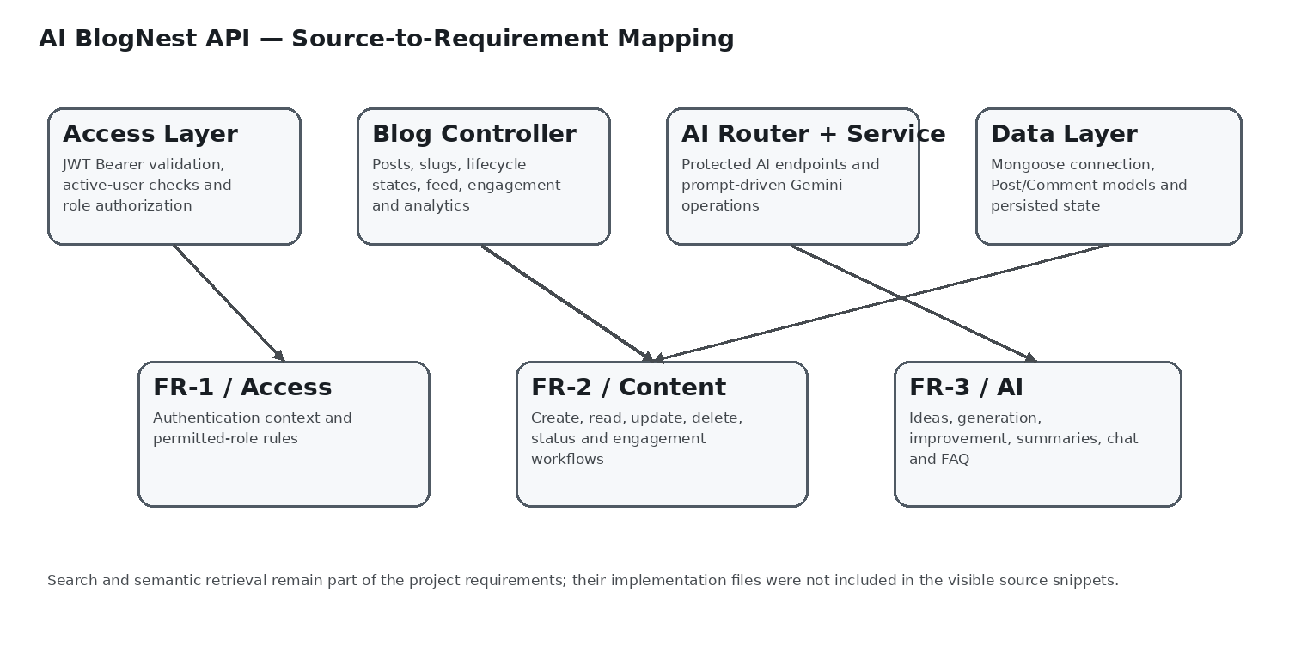
Figure 1. Source-to-requirement mapping for the supplied AI BlogNest backend modules.
Source alignment note: the attached snippets directly show authentication middleware, blog lifecycle logic, AI routing/service functions, comment moderation fields and MongoDB connection handling. Keyword-search and semantic-search requirements are retained because they are part of the supplied Solution Requirements reference and earlier project demonstration, but their dedicated implementation files are not present among the visible snippets in this turn.
Non-Functional Requirements
NFR No. | Non-Functional Requirement | Description
NFR-1 | Usability | The REST API should expose predictable request patterns, clear JSON responses and understandable authentication/authorization error messages so that developers can test the backend consistently.
NFR-2 | Security | Protected resources should use JWT verification, active-account checks and role authorization. Sensitive configuration should remain environment-driven, and AI access should fail clearly when the API key is not configured.
NFR-3 | Reliability | Blog, comment, AI and database operations should pass execution errors to the application's error-handling path and return appropriate HTTP responses for missing records, invalid states and unauthorized actions.
NFR-4 | Performance | Post retrieval should avoid returning unnecessary data by supporting status/category/tag filters and pagination. Database queries should use targeted filters, sorting and counting operations suitable for repeated API requests.
NFR-5 | Availability | Core backend features should remain usable when the Node.js runtime, MongoDB database and configured AI provider are available. Database startup should be handled through a dedicated reusable connection function.
NFR-6 | Scalability | The separation of middleware, routes, controllers, services and models should allow additional AI capabilities, content workflows, moderation rules and discovery features to be added without restructuring the entire backend.
Requirement outcome: AI BlogNest is defined as a secure, modular blogging backend with a controlled content lifecycle, protected AI assistance, moderation-aware comments and extensible discovery capabilities. The requirements are intentionally written around the responsibilities visible in the supplied source rather than copying the reference wording.

